**EX NO: 8 FIRST N PRIME NUMBERS**

**Date :**

**AIM**

To write a python program to find the first n prime numbers.

Input:5

Output:2,3,5

Input: 7

Output:2,3,5,7

Input:11

Output: 2,3,5,7,11

Input:15

Output:2,3,5,7,11,13

**ALGORITHM**

**Step1:** Initializing the value of d to 2

**Step2:**  Get the prime number n

**Step 3:** If the number divisible by d append it.

**Step 4:** Repeat until it reaches the given number

**FLOWCHART**

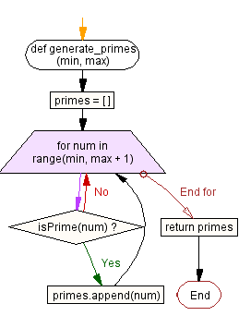

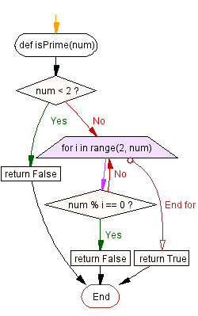

**PRE-LAB QUESTIONS**

1. Sieve of Eratosthenes method to generate prime number
2. Write python logic to generate the nth prime number

**SOURCE CODE**

def generate_primes(min, max):

primes = [ ]

for num in range(min, max + 1):

if isPrime(num):

primes.append(num)

return primes

def isPrime(num):

if num < 2:

return False

for i in range(2, num):

if num % i == 0:

return False

return True

**OUTPUT**

Enter number:15

Output:

2

3

5

7

11

13

**RESULT**

Thus the python program for finding the firsrt n prime numbers was executed and verified successfully.

**POST-LAB QUESTIONS**

1. Modify the program using Sieve of Eratosthenes.
2. Modify the code using list comprehension.